Section-End Project - Lesson 1

Type Casting

**Part 1: A Simple Program**

What follows is a simple program that obtains different types of input, uses some of the input for a computation and then outputs the results.

Create a new project called **Program1a**, enter this program, save, compile and debug it (if you have syntax errors). This is practice for the program you will do as your assignment below (Parts 2-3).

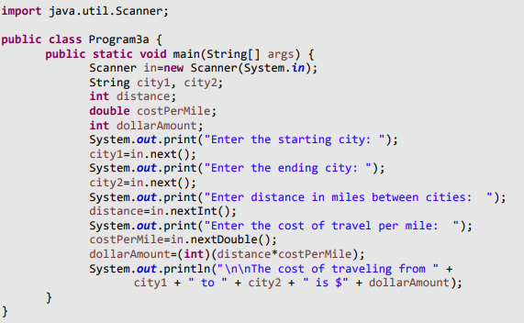

Run the program inputting Cincinnati, Columbus, 115 and .065. Your output should be $7.

**Part 2: Problem Statement**

You will write a similar program to the above, but call it **Program1b**. Here, you will compute a car’s gas mileage and the amount you spend per mile traveled. In particular, ask the user for the following:

* their first name (or their full name) (String),
* the price per gallon of gasoline paid at the time of the last fill-up (double),
* the total amount paid for the fill-up (double), •
* an initial odometer reading (int), •
* a final odometer reading (int).

After inputting these values, compute the total miles drive, the number of gallons of gas used (total amount for fill-up / price per gallon), and the miles per gallon that the car achieved (total miles / number of gallons). Note that number of gallons and miles per gallon will both be doubles. Print this information using System.out.println statements. Below is a sample of the input and the output when running this program.

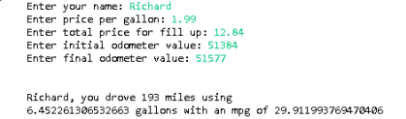

Write this program (make sure you comment the code as you write it). When you have your program written, save and compile it. If it does not compile, fix your syntax errors. Once it does compile, run it on the above input to see if you get the same output. If you get incorrect output, look through your code and try to fix whatever logical errors you might have.

The output is not particularly readable. Let's force the output to look nicer in two ways.

First, we will output the number of gallons used as an int. Do this by changing your numberOfGallons variable (whatever you called it) to an int and casting the value you compute for this variable to an int.

Second, import DecimalFormat (from java.text),

create a variable of type DecimalFormat called df with a format of ##.# and then change the System.out.println statement to format the mpg value using your df.format.

Refer this link [Java DecimalFormat](https://jenkov.com/tutorials/java-internationalization/decimalformat.html" \l ":~:text=Creating%20a%20DecimalFormat%20instance%20is,should%20be%20formatted%20according%20to.) if you are unsure how to do this.

**Part 3: Test Your Program**

Run your program 4 times, once each on the following data. Collect all of the input and output (copy and paste it) and either paste it into a separate text file, or as a comment at the bottom of your source code.



